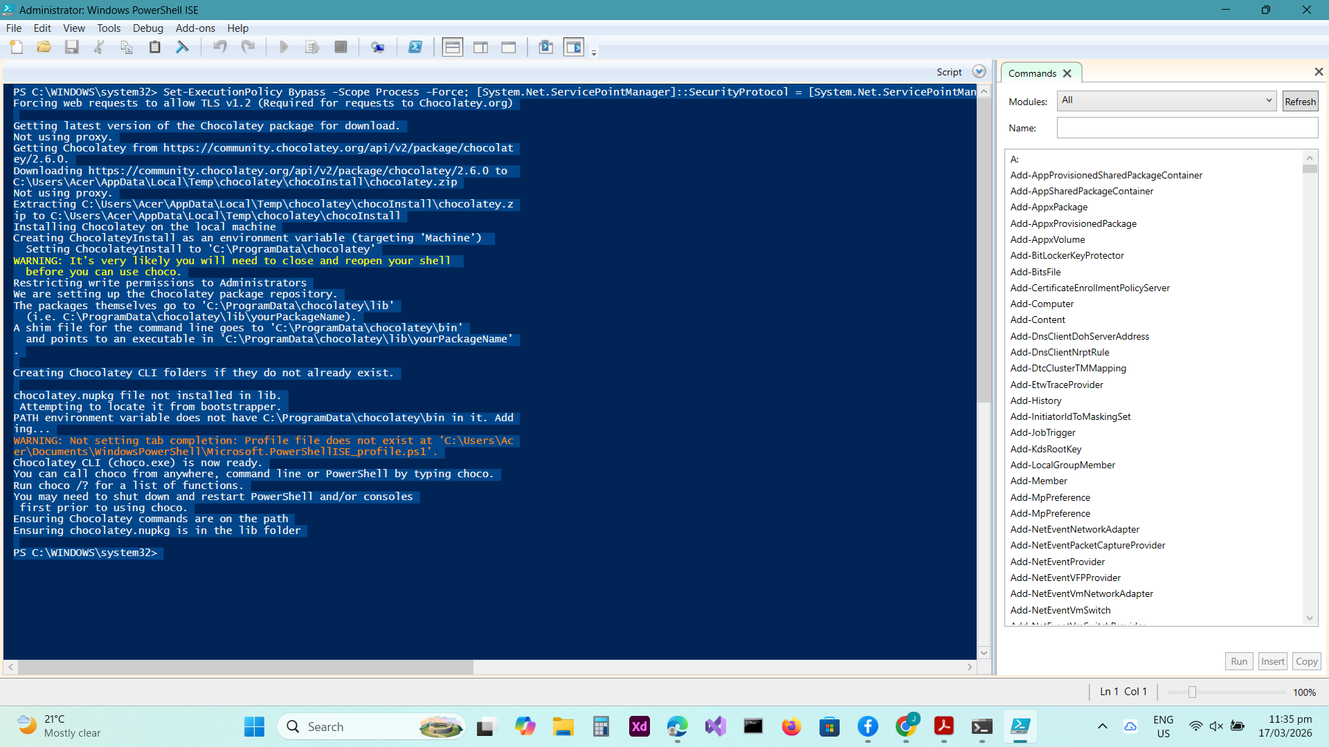

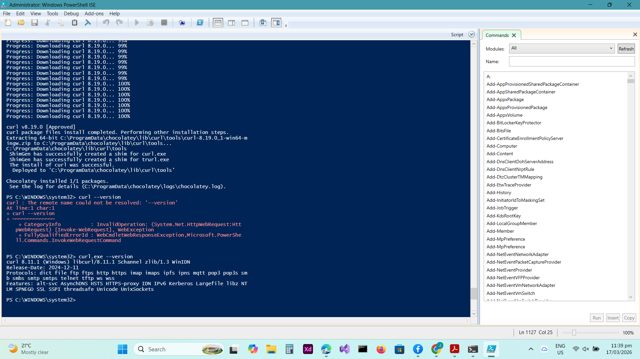

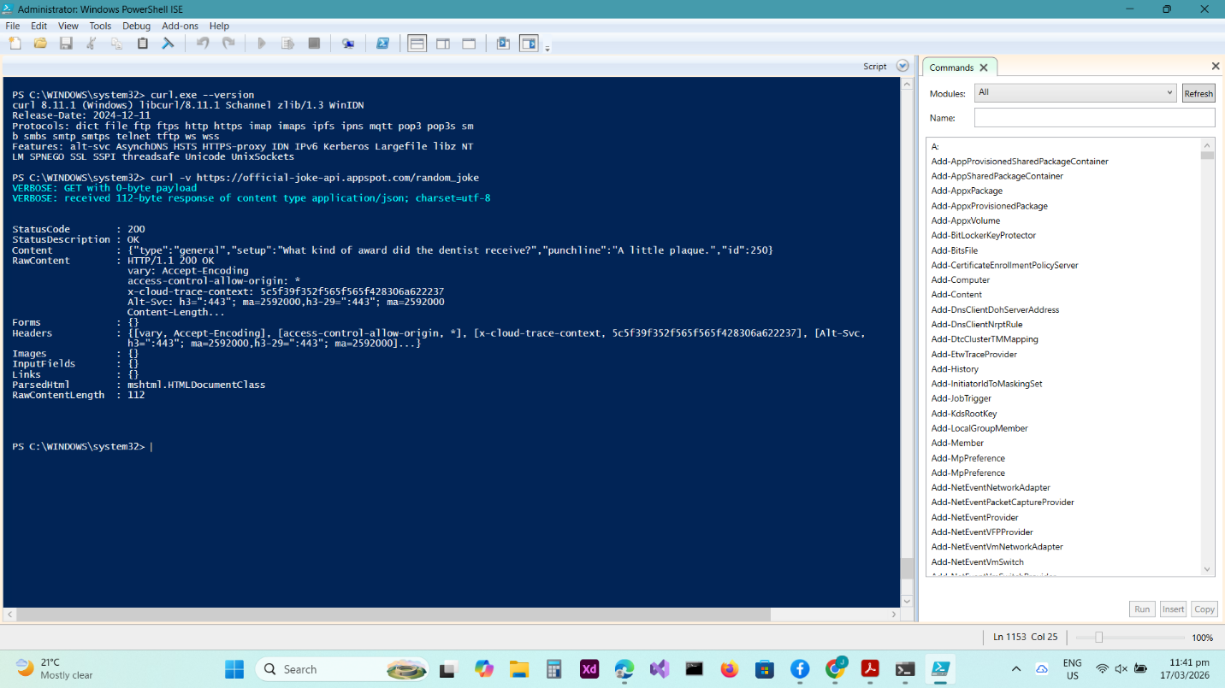

Questions
- Identify the Method used in the output.
- GET
- Identify one Header returned by the server (e.g., Content-Type).
- access-control-allow-origin
- What format is the Payload (the actual joke data) returned in?
- JSON

